**Coles store manager asks staff to work for pizza**

1/18

[9News.com.au logo9News.com.au](http://www.9news.com.au/)

Coles has come under fire after one of its store trainee managers in Perth asked his staff to work for pizza and no pay for four hours today.

The unnamed manager asked his **65-strong** workforce for the **"free labour"** in a notice posted to the store's staff message board, [ABC Radio Perth](https://soundcloud.com/720abcperth/pizza-for-pay-boss-asks-staff-to-work-for-free) reports.

"I'm asking team members to give me **4hrs free** labour. Yes, it is a big ask and I would not be requesting this unless it was absolutely necessary," the notice said.

He asked workers to help them work through six pallets of stock as well as 78 cages of stock today.

"I plan to kick off the evening at **5:30pm and work through to 9:30pm**. Pizza will be plentiful at 9:30pm."

The supermarket giant was alerted to the notice after staff members contacted WA's Shop, Distributive and Allied Workers Association to complain.

"We immediately got in contact with the manager and told him this was unacceptable and it wouldn't be allowed," association WA secretary Peter O'Keefe told ABC radio.

"We also raised it with Coles head office… Coles at the senior level is a gasp that he actually took this step."

In a statement to ABC Radio Perth, Coles said the notice in the store was "completely out of step with Coles' way of working". It also promised "any team members working at that time would be paid as normal."

The Fair Work Commission last month announced Sunday and public holiday rates would be reduced for workers in hospitality, retail and fast-food jobs and that this would lead to increased services and trading hours.

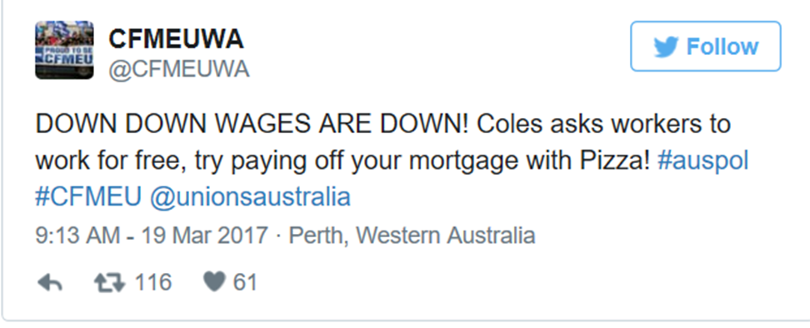The federal government is supportive of the change.

